Bound in Hope:
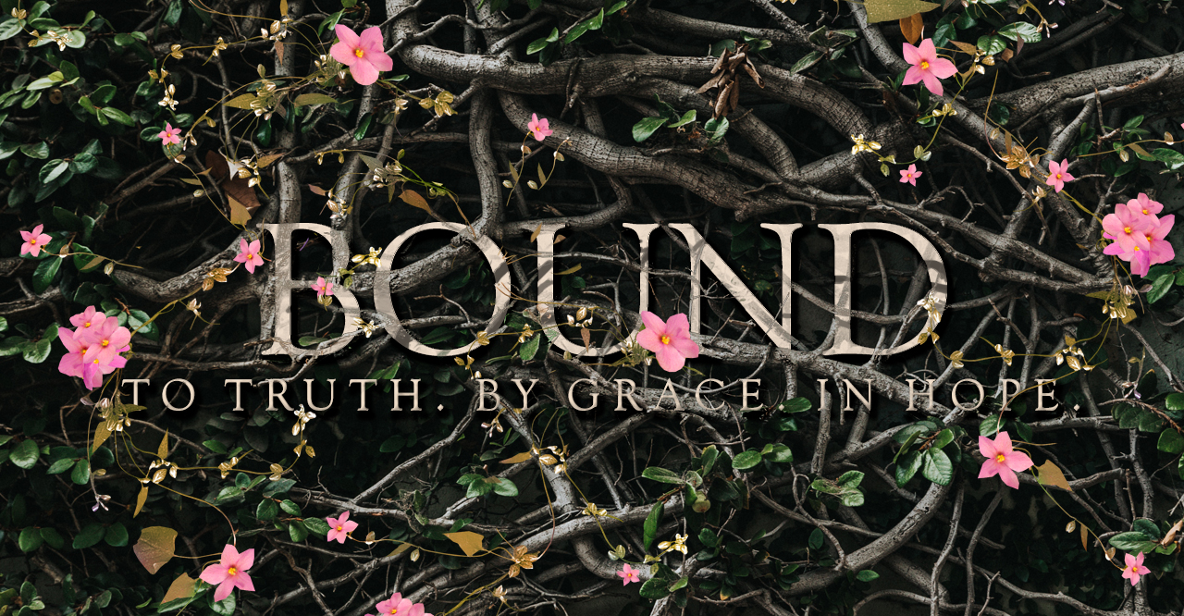

The Book of 1 Peter
“He has caused us to be born again to a living hope” ~ 1 Pet. 1:3

Teacher  Jamie Hoos  Email  jamiehoos7@gmail.com  Website  www.jamiehoos.com  Facebook  @jamiehoosteachingministries | Bible Study Overview  Scripture teaches that real hope is ours in Christ. The world we live in is wasting away but our hope is eternal, secure and it is absolutely foundational for believers. What would your daily life look like if you understood, lived, and walked with a steadfast hope that never wavered despite the failing circumstances around you? How would this hope impact the people around you? Join us in this study as we learn and grow together.  Bible Study Format  This study has two meeting options: in-person at Green Ridge Baptist Church or online via Facebook @ the Jamie Hoos Teaching Ministries page, or you may choose to do a combination of both. Both formats will include the lessons, viewer guide, and homework as well as group discussions. Please note: The in-person group will be one week ahead of the other group.

Online Group Schedule
Week | Title & Text Covered in Class |  | Homework Reading
Intro Week: Jan. 25 | A Journey of Passion, Passivity & Power | Ch. 1: 1-12
Session 1: Feb. 1 | There’s A Living Hope (Ch. 1: 1-12) | Ch. 1: 13-25
Session 2: Feb. 8 | Called to a Promise (Ch. 1: 13-25) | Ch. 2: 1-10
Session 3: Feb. 15 | His People, His Mercy (Ch. 2: 1-10) | Ch. 2: 11 -25
Session 4: Feb. 22 | Keeping Your Conduct (Ch. 2: 11-25) | Ch. 3: All
Session 5: Mar. 1 | Five Questions for the Foolish (Ch.3: All) | Ch. 4: All
Session 6: Mar. 8 | Suffering & Serving (Ch. 4: All) | Ch. 5: All
Session 7: Mar. 15 | The God of All Grace (Ch. 5: All)
Bonus Week: Mar. 22 | A Wife’s Precious Adornment (Ch. 3: 1-7)

